1. **What does an empty dictionary's code look like?**

Ans: Screenshot 2023-10-17 211223

1. **What is the value of a dictionary value with the key 'foo' and the value 42?**

Ans:*If you have a dictionary with the key 'foo' and the value 42, it would look like this in Python:*

Screenshot 2023-10-17 211402

*In this dictionary, 'foo' is the key, and 42 is the associated value. You can access the value associated with the key 'foo' using `my_dict['foo']`, which would return `42`. For example:*

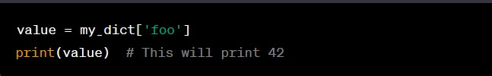

1. **What is the most significant distinction between a dictionary and a list?**

Ans: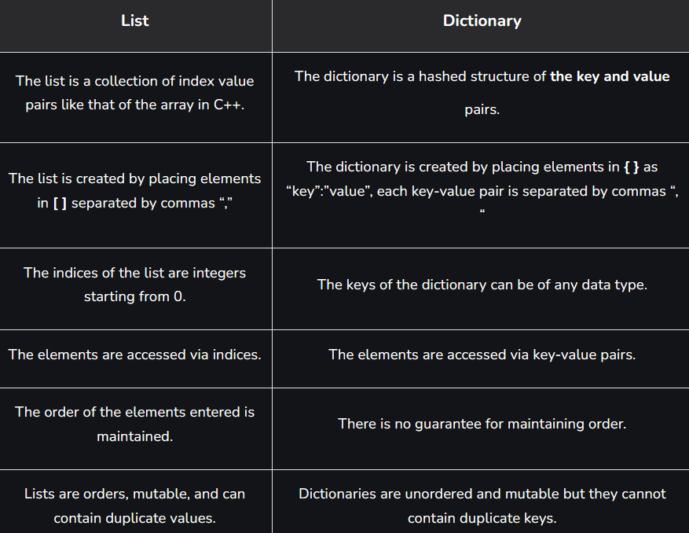

1. **What happens if you try to access spam['foo'] if spam is {'bar': 100}?**

Ans:*If you try to access `spam['foo']` and `spam` is `{'bar': 100}`, you will get a `KeyError` because the key 'foo' does not exist in the dictionary `spam`. In Python, attempting to access a non-existent key in a dictionary using square brackets will result in a `KeyError` exception.*

*Here's an example of what would happen:*

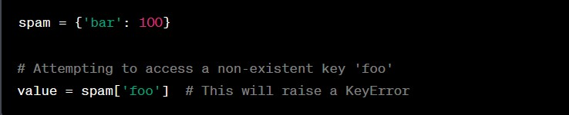

*To avoid this error, you should ensure that the key you're trying to access exists in the dictionary or use the `get` method to provide a default value in case the key is not found, like this:*

Screenshot 2023-10-17 211830

1. **If a dictionary is stored in spam, what is the difference between the expressions 'cat' in spam and 'cat' in spam.keys()?**

Ans: *Both expressions `'cat' in spam` and `'cat' in `spam.keys()` are used to check if a key exists in a dictionary `spam`, but they have some differences in their behavior:*

*1. `'cat' in spam`:*

*- This expression checks if the key `'cat'` exists in the dictionary `spam`.*

*- It returns a Boolean value (`True` or `False`).*

*- It directly checks if the key is in the dictionary without explicitly calling the `keys()` method. This is the more common and concise way to check for key existence.*

*2. `'cat' in spam.keys()`:*

*- This expression first retrieves all the keys in the dictionary `spam` by calling the `keys()` method, which returns a view of the dictionary's keys.*

*- Then, it checks if the key `'cat'` exists in this view of keys.*

*- It also returns a Boolean value (`True` or `False`).*

*In terms of functionality, both expressions will tell you if the key `'cat'` exists in the dictionary. However, the `'cat' in spam` expression is generally more efficient and concise because it doesn't need to create an intermediate view of keys. It directly checks for key existence in the dictionary itself.*

*Here's an example to illustrate:*

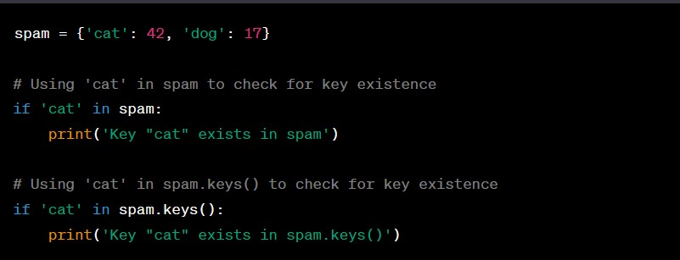

*Both of these `if` statements will print the message because the key `'cat'` exists in the dictionary `spam`.*

1. **If a dictionary is stored in spam, what is the difference between the expressions 'cat' in spam and 'cat' in spam.values()?**

Ans: *The expressions `'cat' in spam` and `'cat' in spam.values()` are used to check the presence of a specific value ('cat' in this case) within a dictionary `spam`, but they have different purposes and behavior:*

*1. `'cat' in spam`:*

*- This expression checks if the key `'cat'` exists in the dictionary `spam`.*

*- It returns a Boolean value (`True` or `False`).*

*- It directly checks if the key is in the dictionary without looking at the values within the dictionary.*

*2. `'cat' in spam.values()`:*

*- This expression checks if the value `'cat'` exists within the values of the dictionary `spam`.*

*- It returns a Boolean value (`True` or `False`).*

*- It checks if the specified value is present in any of the values in the dictionary, regardless of the associated keys.*

*Here's an example to illustrate the difference:*

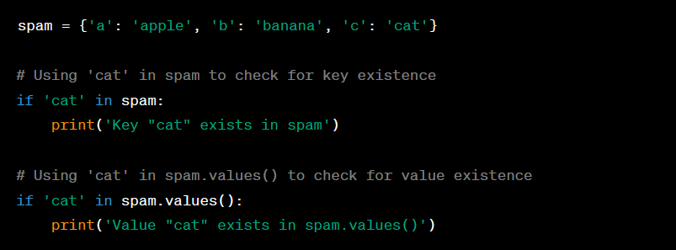

*In this example, the first `if` statement will not execute because the key `'cat'` does not exist in the dictionary `spam`. The second `if` statement will execute because the value `'cat'` exists within the values of the dictionary.*

7. **What is a shortcut for the following code?**

**if 'color' not in spam:**

**spam['color'] = 'black'**

Ans:*You can use the `setdefault()` method as a shortcut to achieve the same result without explicitly checking if the key 'color' exists in the dictionary `spam`. Here's how you can use `setdefault()`:*

**

*The `setdefault()` method checks if the key 'color' exists in `spam`. If it does, it returns the existing value. If 'color' is not in the dictionary, it adds the key 'color' with the default value 'black'. This provides a more concise way to achieve the same outcome.*

1. **How do you "pretty print" dictionary values using which module and function?**

Ans:*To "pretty print" dictionary values in Python, you can use the `pprint` module from the `pprint` library (pretty-print library), which provides the `pprint()` function for nicely formatting the output. The `pprint` module is particularly useful when you want to print complex data structures like dictionaries in a more human-readable and organized way.*

*Here's how you can use it:*

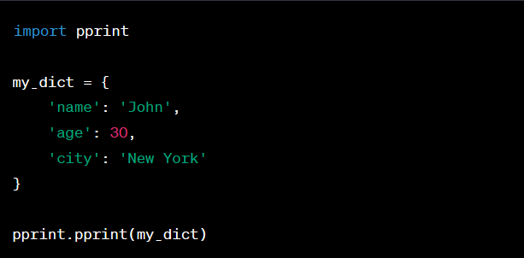

*This will print the dictionary `my_dict` in a more readable and formatted manner. The `pprint()` function from the `pprint` module automatically adds line breaks and indentation to make the data structure easier to read, especially when it contains nested dictionaries or lists.*

*Remember to import the `pprint` module before using it, as shown in the example.*